**CMPE 282 CLOUD SERVICES**

**HOMEWORK - I**

**AWS | Azure AD**

**TEAM SPARTANS**

Mukesh Ranjan Sahay

Thirumalai Nambi Doss Palani

Sudha Amarnath

Muthu Kumar Sukumaran

**AWS DIRECTORY SERVICE**

**Step 1**: In the AWS Console select the Directory Services from the list of services available and choose to set up a new directory.

**Step 2**: To set up a directory, select the type of directory from the available options.

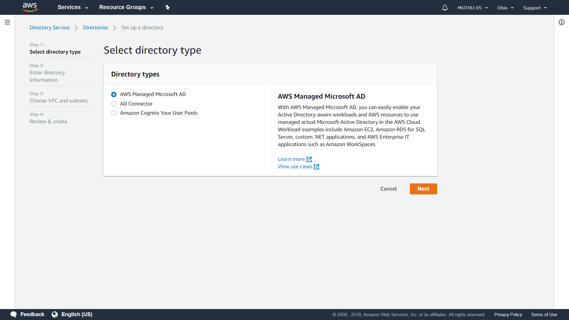

* **AWS Managed Microsoft AD** allows the user to manage the Microsoft Active Directory in the AWS Cloud using AWS resources.
* **AD Connector** redirects any directory requests to the existing Microsoft Active Directory without caching any information in the cloud. AD Connector comes in two sizes based upon the size of the users.
* **Amazon Cognito Your User Pools** permits to enhance the application with features like user registration and sign-in.

**Step 3**: Enter the directory information like Directory DNS Name, Directory NetBIOS name, Directory description, the type of edition (Standard Edition and Enterprise Edition) and Admin Password.

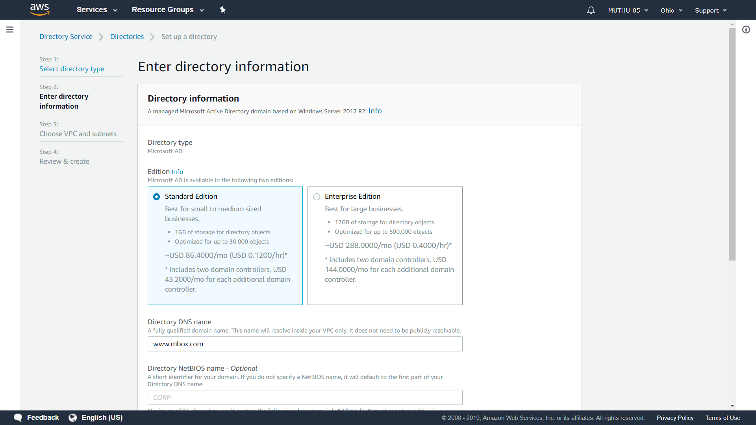

**Step 4**: Choose the VPC and Subnet that contains the directory.

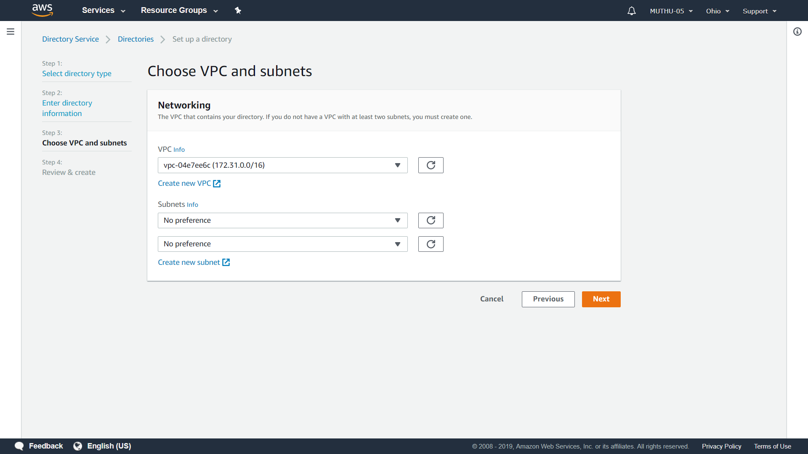

**Step 5**: Review the information regarding the directory and select the Create Directory option.

